IBM TRAININGS 2018-2019 1-ODD-SEM

COURSE | DATES | DEPT | REQUIREMENT | ELIGIBILITY
Enterprise application development and deployment on Cloud using IBM Blue Mix | 5th September  To  8th September | III CSE A, B & III IT | 50 students | As per the HoD’s from CSE & IT
Advanced Database Concepts  DB2 | 14th September  To  23rd September | III ECE A,B,C & III EEE | 50 students  +  50 students | As per the HoD’s from ECE & EEE
Learning Business Intelligence using IBM Cognos and Foundation Course in Business Analytics using Cognos Insights | 17 September  To  21 September | III CSE A, B & III IT | 50 students  +  50 students | As per the HoD’s from CSE & IT

Enterprise application development and deployment on Cloud using IBM Blue Mix
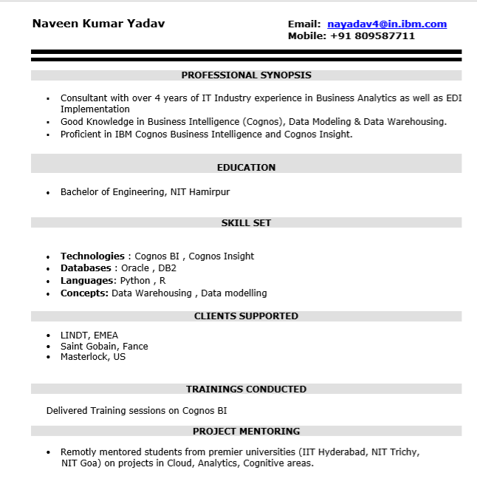
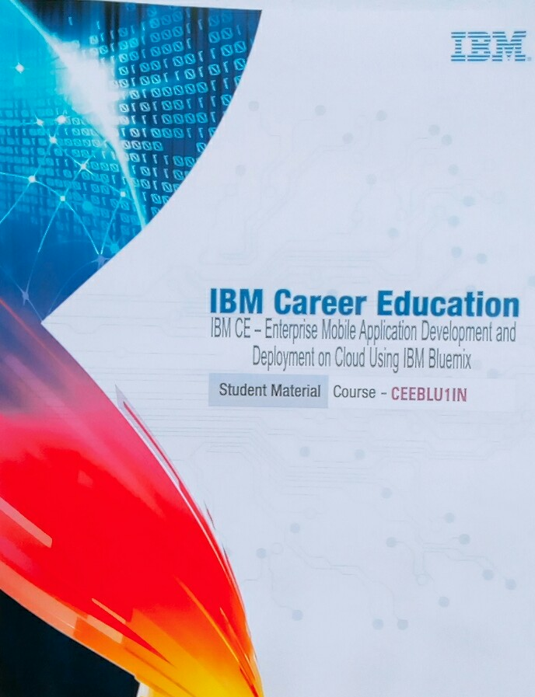
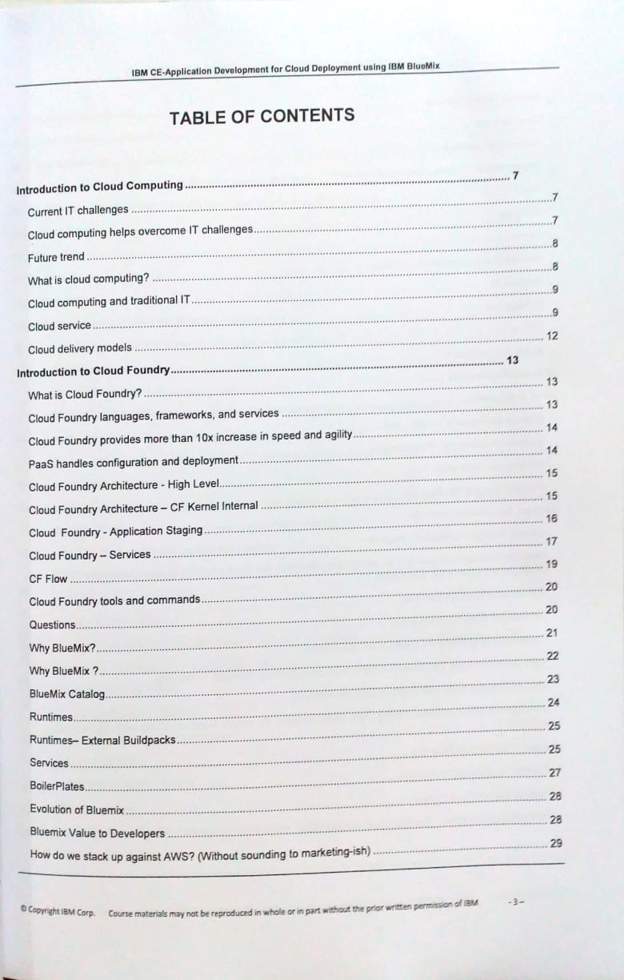
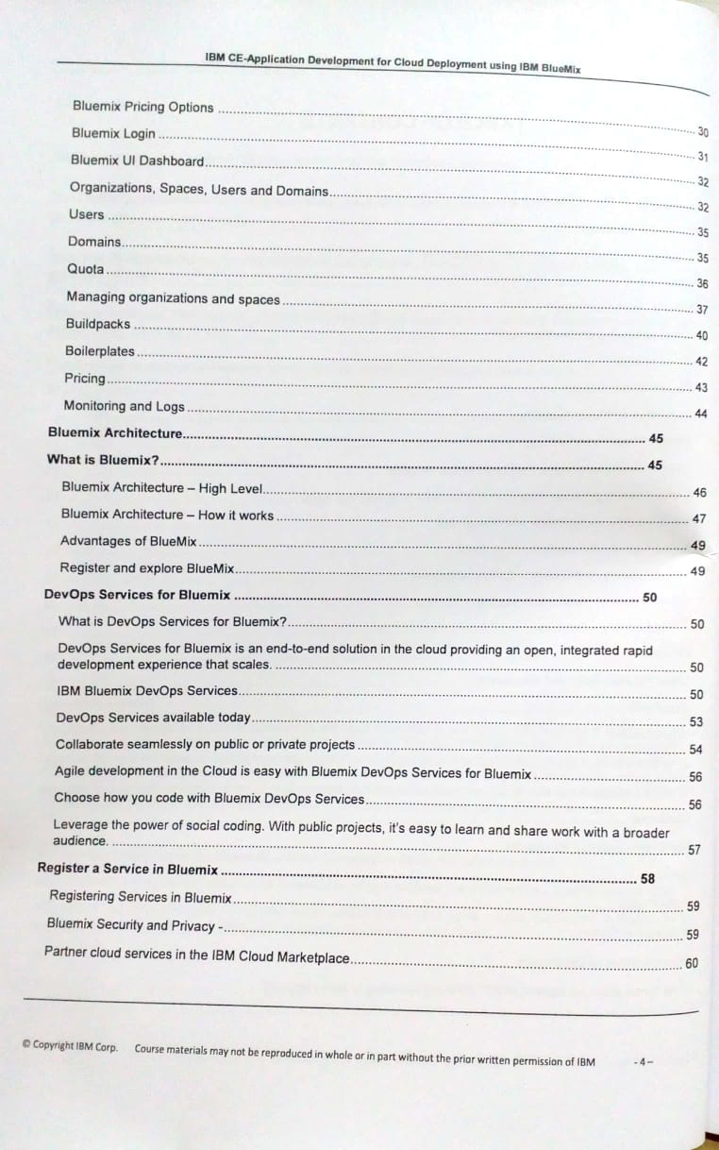
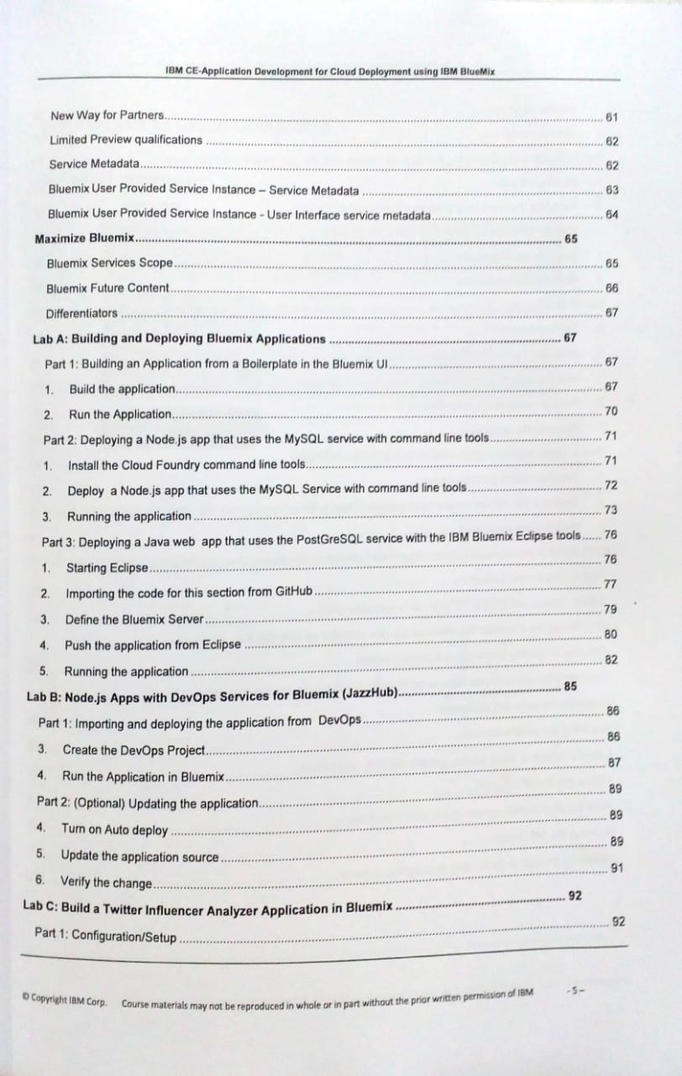
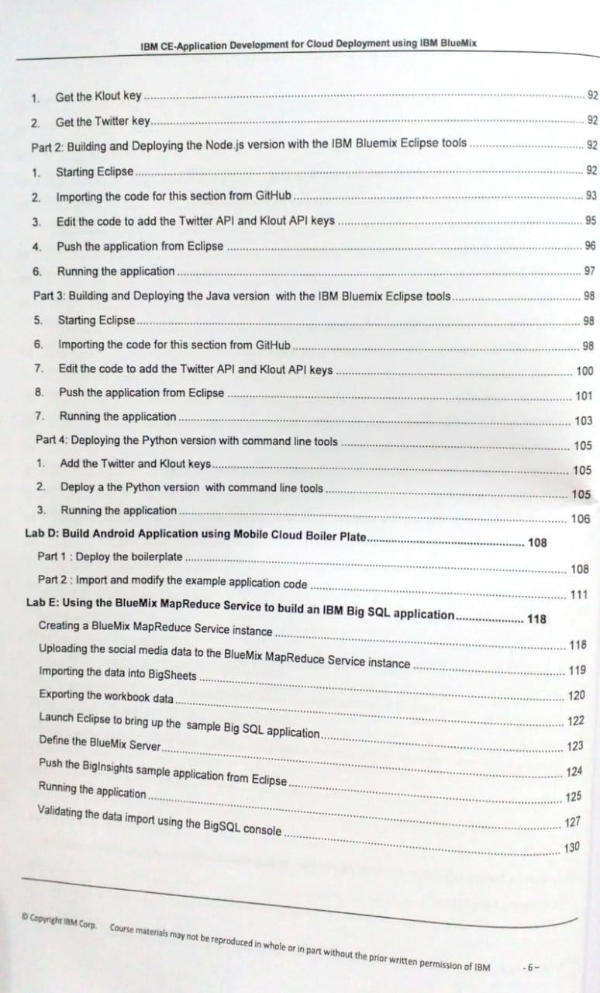
BATCH 1:-
Sl No | Student Name | CE Reg No | Course / Project Name | Technologies Used
1 | GUDAPATI ISAAC SANDEEP BABU | 16NG1A0570 | Enterprise application development and deployment on Cloud using IBM Blue Mix | Bluemix Trail
2 | JALA NITISH | 16NG1A0572 | Enterprise application development and deployment on Cloud using IBM Blue Mix | Bluemix Trail
3 | SIVA TEJA JEEREDDY | 15NG1A0521 | Enterprise application development and deployment on Cloud using IBM Blue Mix | Bluemix Trail
4 | KADIMI VINAY KUMAR | 16NG1A0574 | Enterprise application development and deployment on Cloud using IBM Blue Mix | Bluemix Trail
5 | THOTA SAI GANESH | 16NG1A05B1 | Enterprise application development and deployment on Cloud using IBM Blue Mix | Bluemix Trail
6 | PHANI MADHU AKULA | 16NG1A0598 | Enterprise application development and deployment on Cloud using IBM Blue Mix | Bluemix Trail
7 | SURAPANENI JASWANTH CHOWDARY | 16NG1A05A8 | Enterprise application development and deployment on Cloud using IBM Blue Mix | Bluemix Trail
8 | DEVENDLA SASIDHAR BABU | 16NG1A0567 | Enterprise application development and deployment on Cloud using IBM Blue Mix | Bluemix Trail
9 | PUPPALA SAI AVINASH | 16NG1A05A2 | Enterprise application development and deployment on Cloud using IBM Blue Mix | Bluemix Trail
10 | DIYYALA PAVAN KALYAN | 16NG1A0568 | Enterprise application development and deployment on Cloud using IBM Blue Mix | Bluemix Trail
11 | GOVINDU VAMSI KRISHNA | 16NG1A0569 | Enterprise application development and deployment on Cloud using IBM Blue Mix | Bluemix Trail
12 | HARSHAD BALAJI JAMULA | 16NG1A0571 | Enterprise application development and deployment on Cloud using IBM Blue Mix | Bluemix Trail
13 | KOMMU LAKSHMANA SWAMY | 16NG1A0583 | Enterprise application development and deployment on Cloud using IBM Blue Mix | Bluemix Trail
14 | TAMIDALA WINNER PRABHAS | 16NG1A05A9 | Enterprise application development and deployment on Cloud using IBM Blue Mix | Bluemix Trail
15 | VASTAVI BHASKAR | 16NG1A05B4 | Enterprise application development and deployment on Cloud using IBM Blue Mix | Bluemix Trail
16 | CHAGANTIPATI NAGARJUNA | 17NG5A0503 | Enterprise application development and deployment on Cloud using IBM Blue Mix | Bluemix Trail
17 | BEERAM LAKSHMI KEERTHI | 16NG1A0504 | Enterprise application development and deployment on Cloud using IBM Blue Mix | Bluemix Trail
18 | CHEEKATI NAGA SUDHA RANI | 16NG1A0507 | Enterprise application development and deployment on Cloud using IBM Blue Mix | Bluemix Trail
19 | PAMARTHI SRI SAI DURGA | 16NG1A0542 | Enterprise application development and deployment on Cloud using IBM Blue Mix | Bluemix Trail
20 | SHAIK RIZWANA | 16NG1A0554 | Enterprise application development and deployment on Cloud using IBM Blue Mix | Bluemix Trail
21 | SHAIK SHABANA BANOE | 16NG1A0555 | Enterprise application development and deployment on Cloud using IBM Blue Mix | Bluemix Trail
22 | GUNTUPALLI HIMA DEEPTHI | 16NG1A0516 | Enterprise application development and deployment on Cloud using IBM Blue Mix | Bluemix Trail
23 | LAVU NAGA BHARGAVI | 16NG1A0527 | Enterprise application development and deployment on Cloud using IBM Blue Mix | Bluemix Trail
24 | BHOGADULA CHAITANYA SAI KUMAR | 16NG1A0505 | Enterprise application development and deployment on Cloud using IBM Blue Mix | Bluemix Trail
25 | KAKITHA MANOJ | 16NG1A0519 | Enterprise application development and deployment on Cloud using IBM Blue Mix | Bluemix Trail
26 | KELWIN PITTA | 16NG1A0523 | Enterprise application development and deployment on Cloud using IBM Blue Mix | Bluemix Trail
27 | KASAGANI SRINIVAS SABARISH | 16NG1A0522 | Enterprise application development and deployment on Cloud using IBM Blue Mix | Bluemix Trail
28 | RAGULA MANASA GAYATHRI | 16NG1A05A3 | Enterprise application development and deployment on Cloud using IBM Blue Mix | Bluemix Trail
29 | DASARI SHANMUKHA SRI KEERTHI | 16NG1A0510 | Enterprise application development and deployment on Cloud using IBM Blue Mix | Bluemix Trail
30 | S KUSHAL | 16NG1A0550 | Enterprise application development and deployment on Cloud using IBM Blue Mix | Bluemix Trail
31 | SHAIK GALIB BASHA | 16NG1A0553 | Enterprise application development and deployment on Cloud using IBM Blue Mix | Bluemix Trail
32 | CHOWTAPALLI ARIC MICHAEL | 16NG1A0508 | Enterprise application development and deployment on Cloud using IBM Blue Mix | Bluemix Trail
33 | SAMUNURU SAI KRISHNA VARA PRASAD RAJU | 16NG1A0552 | Enterprise application development and deployment on Cloud using IBM Blue Mix | Bluemix Trail
34 | CHANDRA SRI MANIKANTA PUSHPAK KUMAR | 16NG1A0506 | Enterprise application development and deployment on Cloud using IBM Blue Mix | Bluemix Trail
35 | GOGINENI VINAY | 16NG1A1216 | Enterprise application development and deployment on Cloud using IBM Blue Mix | Bluemix Trail
36 | AKKINENI SUSHMITA | 16NG1A1203 | Enterprise application development and deployment on Cloud using IBM Blue Mix | Bluemix Trail
37 | CH.PRATHYUSHA | 16NG1A1206 | Enterprise application development and deployment on Cloud using IBM Blue Mix | Bluemix Trail
38 | CHENNU PUJITHA | 16NG1A1207 | Enterprise application development and deployment on Cloud using IBM Blue Mix | Bluemix Trail
39 | Chinthabathini Sowrab Kowsal | 16NG1A1209 | Enterprise application development and deployment on Cloud using IBM Blue Mix | Bluemix Trail
40 | DONEPUDI SAI KIRAN | 16NG1A1213 | Enterprise application development and deployment on Cloud using IBM Blue Mix | Bluemix Trail
41 | MUGANDA NAGA SAI TEJA | 16NG1A1230 | Enterprise application development and deployment on Cloud using IBM Blue Mix | Bluemix Trail
42 | ABBINENI RAMSAI ROHITH | 16NG1A1201 | Enterprise application development and deployment on Cloud using IBM Blue Mix | Bluemix Trail
43 | KOMMINENI MANI JAYESH | 16NG1A1224 | Enterprise application development and deployment on Cloud using IBM Blue Mix | Bluemix Trail
44 | VADIGINA GOWTHAM | 16NG1A1240 | Enterprise application development and deployment on Cloud using IBM Blue Mix | Bluemix Trail
45 | MANNAM SIVA RAMA KRISHNA | 16NG1A1228 | Enterprise application development and deployment on Cloud using IBM Blue Mix | Bluemix Trail
46 | Simran Singh | 16NG1A1237 | Enterprise application development and deployment on Cloud using IBM Blue Mix | Bluemix Trail
47 | BEJAWADA BALA CHANDRUDU | 16NG1A1204 | Enterprise application development and deployment on Cloud using IBM Blue Mix | Bluemix Trail
48 | CHEPPALA HARISH | 16NG1A1208 | Enterprise application development and deployment on Cloud using IBM Blue Mix | Bluemix Trail
49 | DATLA CHANDRA SUBRAHMANYAM RAJU | 16NG1A1211 | Enterprise application development and deployment on Cloud using IBM Blue Mix | Bluemix Trail
50 | SURAM SRINIVAS | 16NG1A1238 | Enterprise application development and deployment on Cloud using IBM Blue Mix | Bluemix Trail

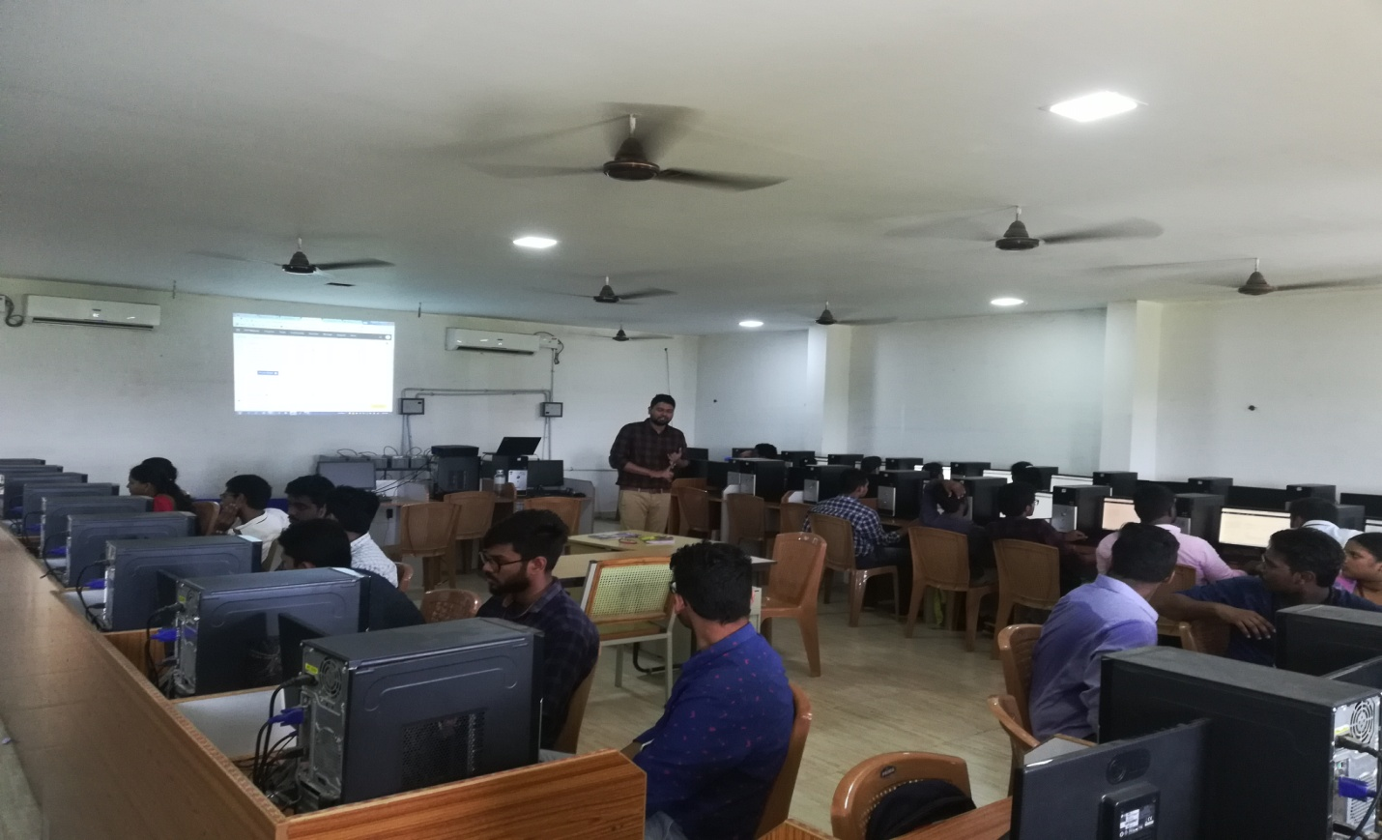
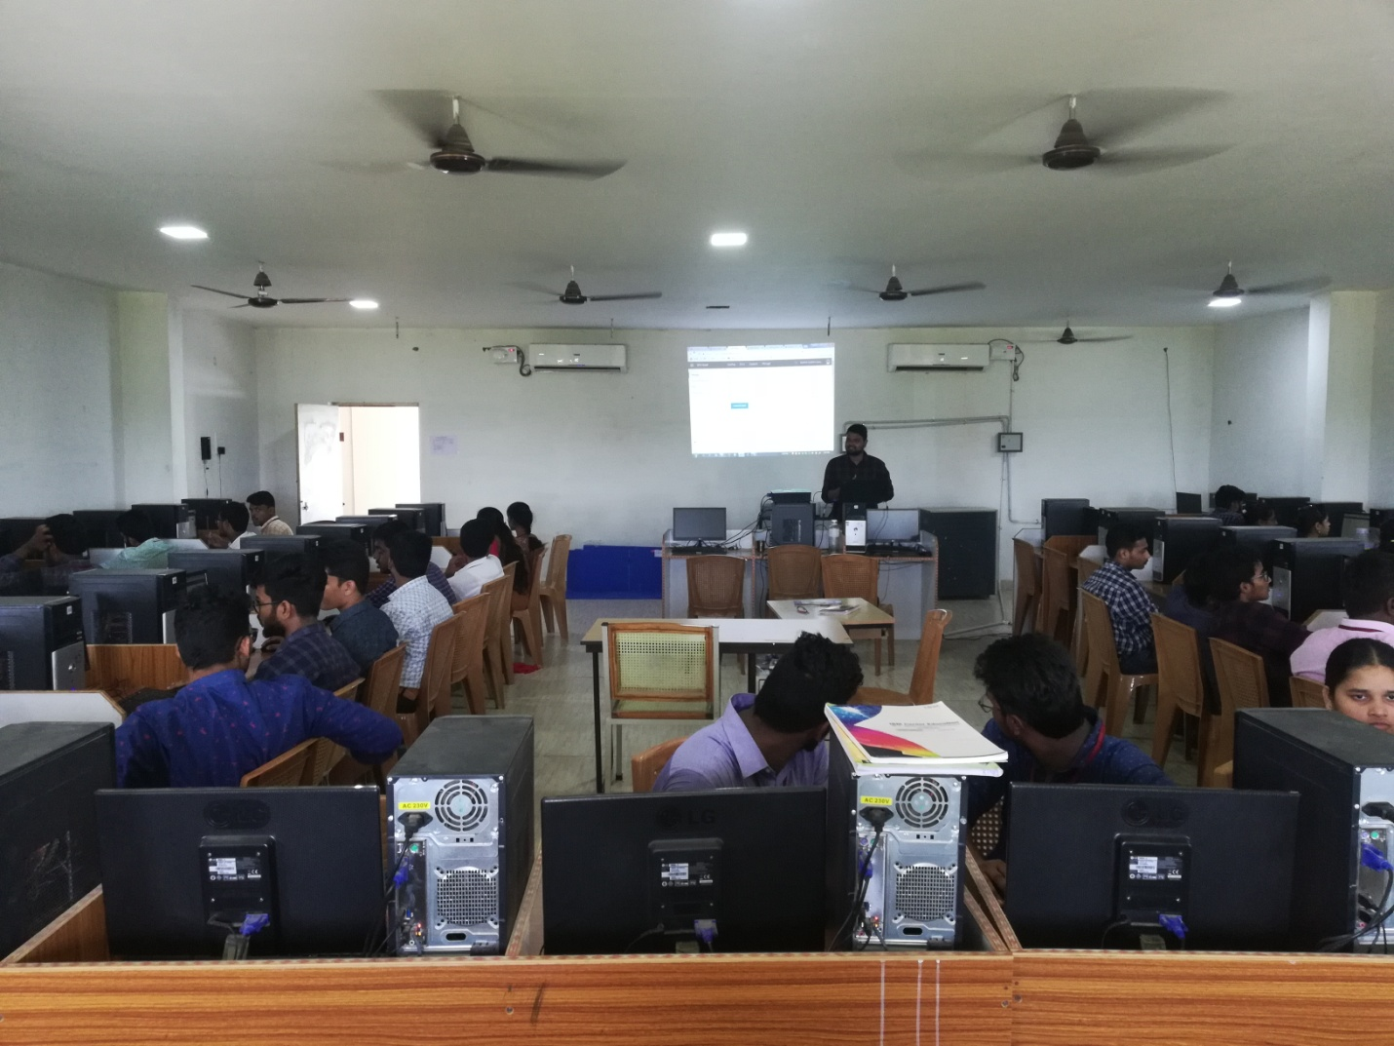

Learning Business Intelligence using IBM Cognos and Foundation Course in Business Analytics using Cognos Insights
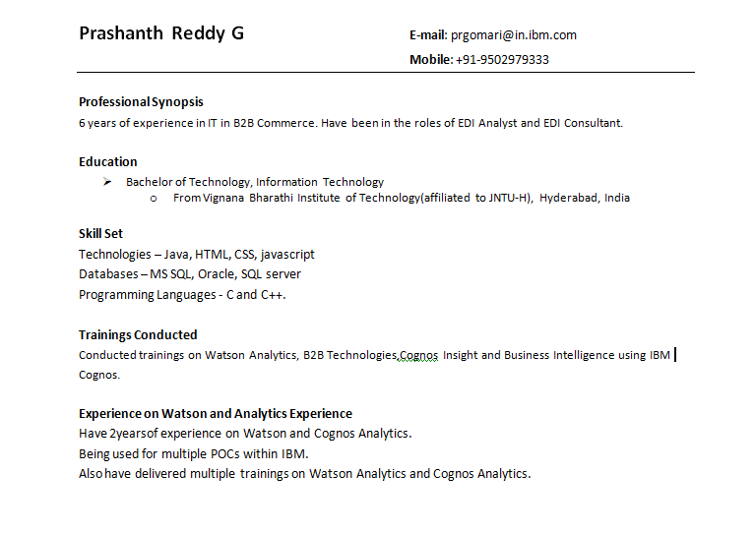

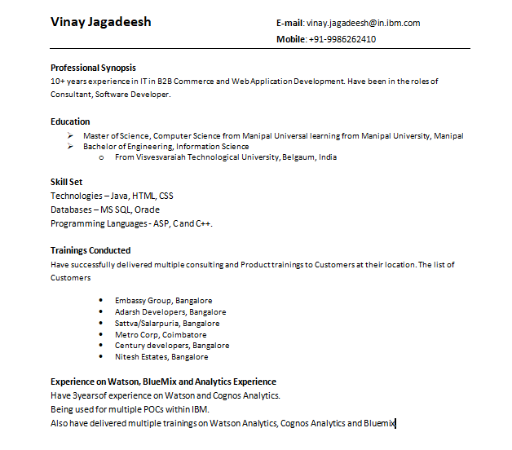
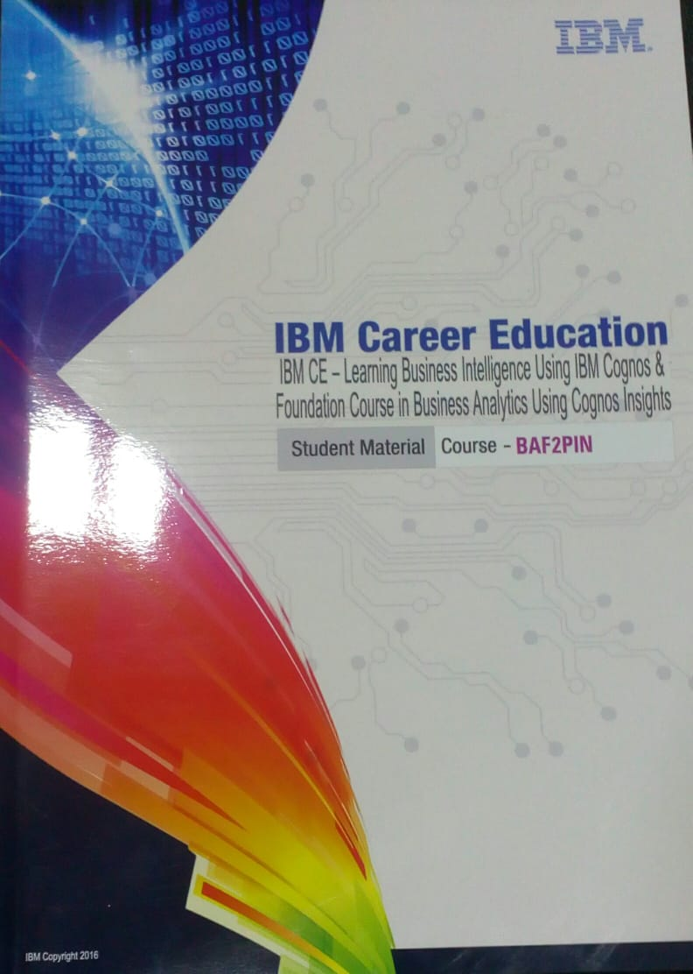
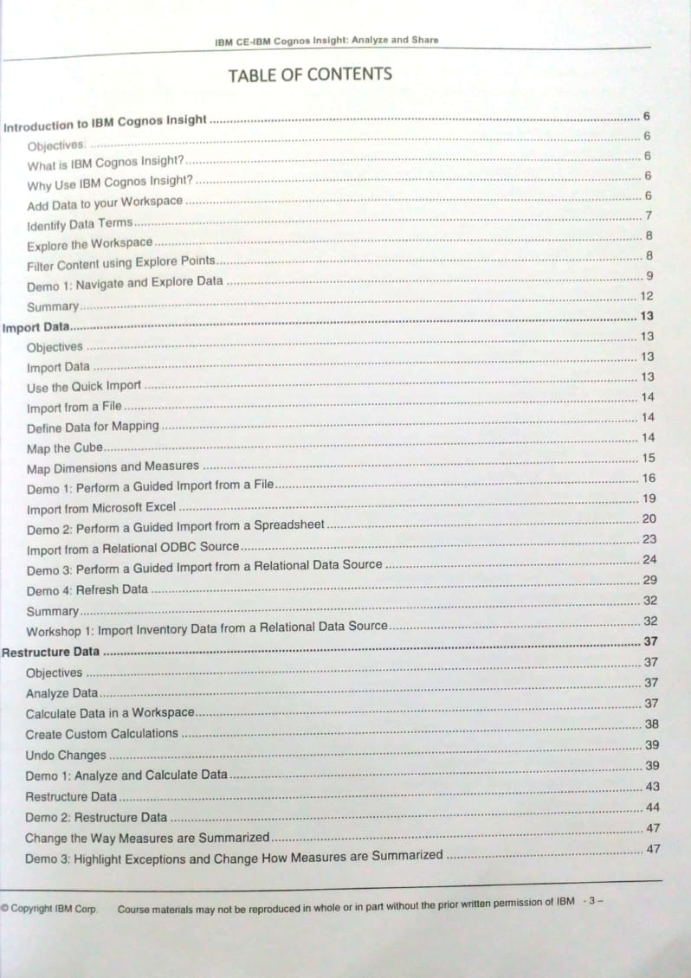
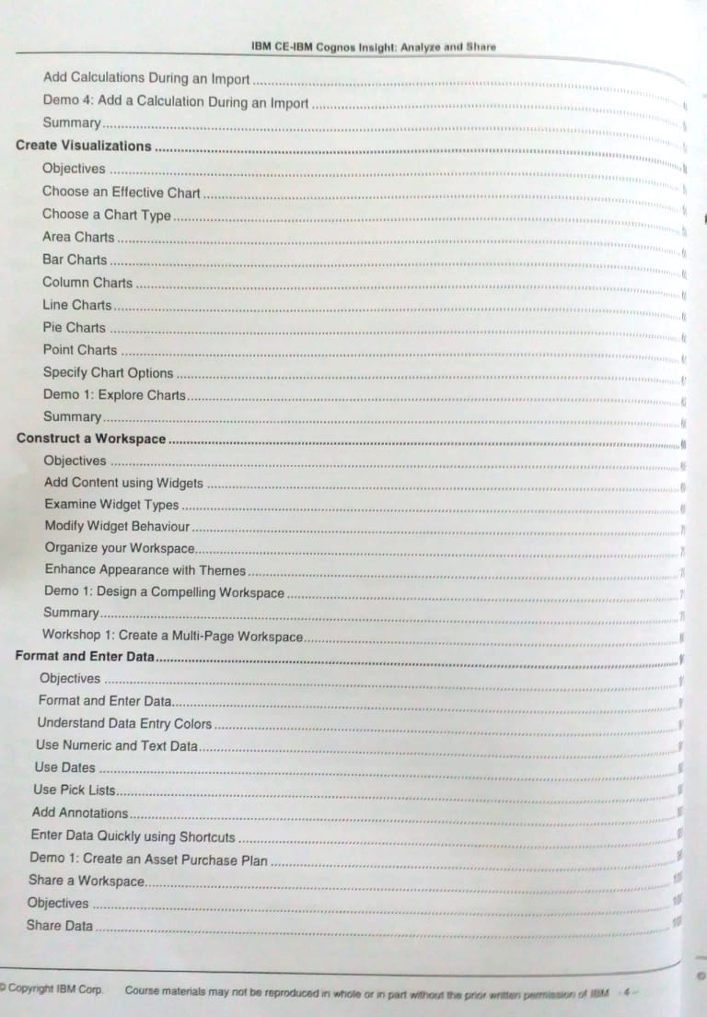
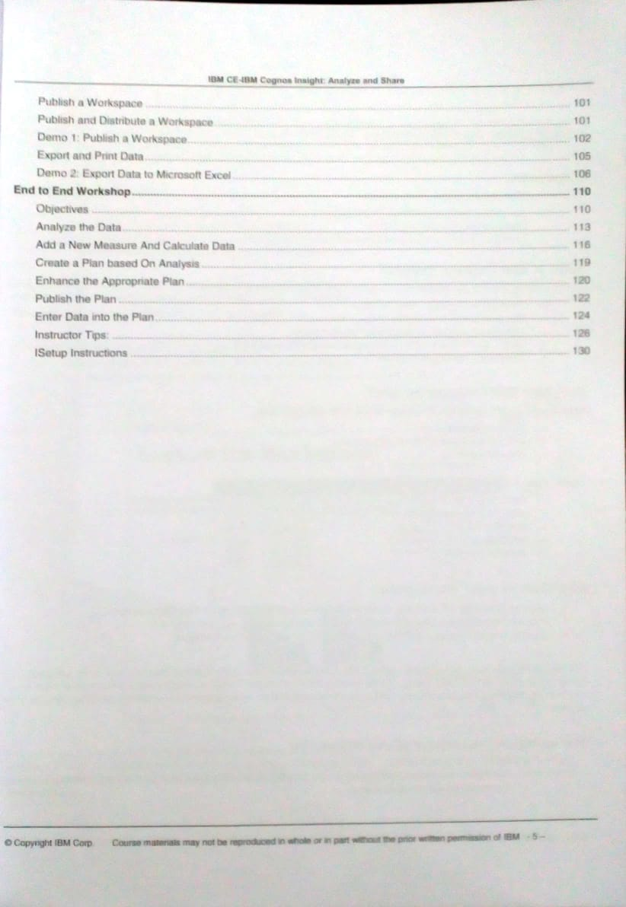Batch 1:- CSE & IT
slno | Student Name | CE Reg No | Course / Project Name | Technologies  Used
1 | ADDEPALLI TEJA SRI | 16NG1A0501 | Learning BI using Cognos & Busines Analytics using Cognos Insights | Cognos, Db2
2 | BALUSU LIKHITHA SRAVYA | 16NG1A0503 | Learning BI using Cognos & Busines Analytics using Cognos Insights | Cognos, Db2
3 | DUNGA LAVANYA | 16NG1A0512 | Learning BI using Cognos & Busines Analytics using Cognos Insights | Cognos, Db2
4 | GHANTA YOGENDRANAGA SATWIK | 16NG1A0514 | Learning BI using Cognos & Busines Analytics using Cognos Insights | Cognos, Db2
5 | GURINDAGUNTA PRAISY | 16NG1A0517 | Learning BI using Cognos & Busines Analytics using Cognos Insights | Cognos, Db2
6 | KALLEM MOUNIKA | 16NG1A0520 | Learning BI using Cognos & Busines Analytics using Cognos Insights | Cognos, Db2
7 | KOLLI DIVYA | 16NG1A0524 | Learning BI using Cognos & Busines Analytics using Cognos Insights | Cognos, Db2
8 | KOLLIPARA DIVYA | 16NG1A0525 | Learning BI using Cognos & Busines Analytics using Cognos Insights | Cognos, Db2
9 | KOLLIPARA PALLAVI | 16NG1A0526 | Learning BI using Cognos & Busines Analytics using Cognos Insights | Cognos, Db2
10 | MADDURI LAKSHMI SWETHA | 16NG1A0528 | Learning BI using Cognos & Busines Analytics using Cognos Insights | Cognos, Db2
11 | MAHALI PRASANNA LAKSHMI | 16NG1A0529 | Learning BI using Cognos & Busines Analytics using Cognos Insights | Cognos, Db2
12 | MALLIKA SULTHANA | 16NG1A0530 | Learning BI using Cognos & Busines Analytics using Cognos Insights | Cognos, Db2
13 | MANDAVALLI VIJAYA LAKSHMI | 16NG1A0532 | Learning BI using Cognos & Busines Analytics using Cognos Insights | Cognos, Db2
14 | MATURI TANDAVA LAKSHMI NAVYA | 16NG1A0534 | Learning BI using Cognos & Busines Analytics using Cognos Insights | Cognos, Db2
15 | MUNGI ANUSHA | 16NG1A0536 | Learning BI using Cognos & Busines Analytics using Cognos Insights | Cognos, Db2
16 | NALLAMOTHU TALANYA | 16NG1A0537 | Learning BI using Cognos & Busines Analytics using Cognos Insights | Cognos, Db2
17 | NARRA RUPA SRI | 16NG1A0541 | Learning BI using Cognos & Busines Analytics using Cognos Insights | Cognos, Db2
18 | PAMU RAJ KIRAN | 16NG1A0543 | Learning BI using Cognos & Busines Analytics using Cognos Insights | Cognos, Db2
19 | POTLURI BHAVANA | 16NG1A0547 | Learning BI using Cognos & Busines Analytics using Cognos Insights | Cognos, Db2
20 | PUTTAGUNTA SANDHYA | 16NG1A0548 | Learning BI using Cognos & Busines Analytics using Cognos Insights | Cognos, Db2
21 | SAMBHANI DURGESH VENKATA AKHIL | 16NG1A0551 | Learning BI using Cognos & Busines Analytics using Cognos Insights | Cognos, Db2
22 | SURYADEVARA PRATYUSHA | 16NG1A0556 | Learning BI using Cognos & Busines Analytics using Cognos Insights | Cognos, Db2
23 | VALLABHANENI TARAKESH | 16NG1A0559 | Learning BI using Cognos & Busines Analytics using Cognos Insights | Cognos, Db2
24 | YANDRAPU GAYATRI | 16NG1A0560 | Learning BI using Cognos & Busines Analytics using Cognos Insights | Cognos, Db2
25 | DAKARAPU NAGA VENKATA CHANDANA SRI | 16NG1A0509 | Learning BI using Cognos & Busines Analytics using Cognos Insights | Cognos, Db2
26 | DOKALA SAI GEETHIKA | 16NG1A0511 | Learning BI using Cognos & Busines Analytics using Cognos Insights | Cognos, Db2
27 | EMMADISETTY VEERA MANIKANTA | 16NG1A0513 | Learning BI using Cognos & Busines Analytics using Cognos Insights | Cognos, Db2
28 | GUNJA RAMA DEVI | 16NG1A0515 | Learning BI using Cognos & Busines Analytics using Cognos Insights | Cognos, Db2
29 | KARNIKULA PREETHANJALI | 16NG1A0521 | Learning BI using Cognos & Busines Analytics using Cognos Insights | Cognos, Db2
30 | CHITTURI AMBICA | 16NG1A1210 | Learning BI using Cognos & Busines Analytics using Cognos Insights | Cognos, Db2
31 | Eluru Sai Krishna | 16NG1A1214 | Learning BI using Cognos & Busines Analytics using Cognos Insights | Cognos, Db2
32 | GALLA PRATHYUSHA | 16NG1A1215 | Learning BI using Cognos & Busines Analytics using Cognos Insights | Cognos, Db2
33 | HAWARALU SRUJANA | 16NG1A1218 | Learning BI using Cognos & Busines Analytics using Cognos Insights | Cognos, Db2
34 | KUCHIPUDI CHARUHASA | 16NG1A1226 | Learning BI using Cognos & Busines Analytics using Cognos Insights | Cognos, Db2
35 | GOLLAPUDI V S S SURYA KUMAR | 16NG1A1217 | Learning BI using Cognos & Busines Analytics using Cognos Insights | Cognos, Db2
36 | KOLLA KOSAL DURGESH | 16NG1A1222 | Learning BI using Cognos & Busines Analytics using Cognos Insights | Cognos, Db2
37 | NARISETTY VENKATA LAKSHMI SRAVYA | 16NG1A1232 | Learning BI using Cognos & Busines Analytics using Cognos Insights | Cognos, Db2
38 | SYKAM DEEPIKA | 16NG1A1239 | Learning BI using Cognos & Busines Analytics using Cognos Insights | Cognos, Db2
39 | UBBISETTI SANTHI | 17NG5A1202 | Learning BI using Cognos & Busines Analytics using Cognos Insights | Cognos, Db2
40 | KOSARAJU LEELA KRISHNA | 16NG1A1225 | Learning BI using Cognos & Busines Analytics using Cognos Insights | Cognos, Db2
41 | SAIAJAY KAKARLA | 16NG1A1234 | Learning BI using Cognos & Busines Analytics using Cognos Insights | Cognos, Db2
42 | KALAPALA PUJITHA | 16NG1A1220 | Learning BI using Cognos & Busines Analytics using Cognos Insights | Cognos, Db2
43 | Kunchala Trishali | 16NG1A1227 | Learning BI using Cognos & Busines Analytics using Cognos Insights | Cognos, Db2
44 | SALI SRAVANI | 16NG1A1235 | Learning BI using Cognos & Busines Analytics using Cognos Insights | Cognos, Db2
45 | Yanamadala Poojitha | 16NG1A1242 | Learning BI using Cognos & Busines Analytics using Cognos Insights | Cognos, Db2
46 | KANDULA LOKESH | 16NG1A1221 | Learning BI using Cognos & Busines Analytics using Cognos Insights | Cognos, Db2
47 | YADALA MOUNIKA | 16NG1A1241 | Learning BI using Cognos & Busines Analytics using Cognos Insights | Cognos, Db2
48 | CHALLA HARISCHANDRA PRASAD | 16NG1A1205 | Learning BI using Cognos & Busines Analytics using Cognos Insights | Cognos, Db2
49 | Nandamuri Bhargavi | 16NG1A1231 | Learning BI using Cognos & Busines Analytics using Cognos Insights | Cognos, Db2
50 | Yetukuri Hema | 16NG1A1243 | Learning BI using Cognos & Busines Analytics using Cognos Insights | Cognos, Db2

BATCH 2:-
slno | Student Name | CE Reg No | Course / Project Name | Technologies  Used
1 | BALA CHARISHMA RATNA | 16NG1A0563 | Learning BI using Cognos & Busines Analytics using Cognos Insights | Cognos, Db2
2 | BANDI VINEETHA | 16NG1A0564 | Learning BI using Cognos & Busines Analytics using Cognos Insights | Cognos, Db2
3 | DASARI NAGA VENKAYYA SAI KIRAN | 16NG1A0566 | Learning BI using Cognos & Busines Analytics using Cognos Insights | Cognos, Db2
4 | KAITEPALLI KIRANMAI | 16NG1A0575 | Learning BI using Cognos & Busines Analytics using Cognos Insights | Cognos, Db2
5 | KANAGALA NAGA LAKSHMI | 16NG1A0576 | Learning BI using Cognos & Busines Analytics using Cognos Insights | Cognos, Db2
6 | KANIKANTI NAVEEN | 16NG1A0578 | Learning BI using Cognos & Busines Analytics using Cognos Insights | Cognos, Db2
7 | KILARI SAI THANUSHA | 16NG1A0581 | Learning BI using Cognos & Busines Analytics using Cognos Insights | Cognos, Db2
8 | KILARU BHANU PHANI VENKAT | 16NG1A0582 | Learning BI using Cognos & Busines Analytics using Cognos Insights | Cognos, Db2
9 | KOPURI PRAMEELA | 16NG1A0584 | Learning BI using Cognos & Busines Analytics using Cognos Insights | Cognos, Db2
10 | MAMILLAPALLI MADHAVI LATHA | 16NG1A0587 | Learning BI using Cognos & Busines Analytics using Cognos Insights | Cognos, Db2
11 | MOHAMMAD ARSHAD | 16NG1A0588 | Learning BI using Cognos & Busines Analytics using Cognos Insights | Cognos, Db2
12 | MUKKAMALA DHANUSHA | 16NG1A0589 | Learning BI using Cognos & Busines Analytics using Cognos Insights | Cognos, Db2
13 | NALADI BALAVARDHAN | 16NG1A0591 | Learning BI using Cognos & Busines Analytics using Cognos Insights | Cognos, Db2
14 | NIDAMANURI RAJITHA | 16NG1A0593 | Learning BI using Cognos & Busines Analytics using Cognos Insights | Cognos, Db2
15 | PARAVATANENI SHARAMILA | 16NG1A0595 | Learning BI using Cognos & Busines Analytics using Cognos Insights | Cognos, Db2
16 | PENNERU VAMSI KRISHNA | 16NG1A0597 | Learning BI using Cognos & Busines Analytics using Cognos Insights | Cognos, Db2
17 | POTLA SAI KUMAR | 16NG1A05A0 | Learning BI using Cognos & Busines Analytics using Cognos Insights | Cognos, Db2
18 | RAMYA PRASANNA EPURI | 16NG1A05A4 | Learning BI using Cognos & Busines Analytics using Cognos Insights | Cognos, Db2
19 | RAVURI MONIKA NAGASAI | 16NG1A05A5 | Learning BI using Cognos & Busines Analytics using Cognos Insights | Cognos, Db2
20 | THESHITHA SWARAJYA LAKSHMI V | 16NG1A05B0 | Learning BI using Cognos & Busines Analytics using Cognos Insights | Cognos, Db2
21 | VANJARAPU BHAVANISHANKAR | 16NG1A05B3 | Learning BI using Cognos & Busines Analytics using Cognos Insights | Cognos, Db2
22 | NANDIPATI DEEPIKA RANI | 17NG5A0504 | Learning BI using Cognos & Busines Analytics using Cognos Insights | Cognos, Db2
23 | ANIL KUMAR ANKALA | 15NG1A0563 | Learning BI using Cognos & Busines Analytics using Cognos Insights | Cognos, Db2
24 | KANCHARLA SURIBABU | 16NG1A0577 | Learning BI using Cognos & Busines Analytics using Cognos Insights | Cognos, Db2
25 | MUTYALA NAGA SRAVANI | 16NG1A0590 | Learning BI using Cognos & Busines Analytics using Cognos Insights | Cognos, Db2
26 | NAVULURI SADWIKA | 16NG1A0592 | Learning BI using Cognos & Busines Analytics using Cognos Insights | Cognos, Db2
27 | PAPISETTY GAYATRI | 16NG1A0594 | Learning BI using Cognos & Busines Analytics using Cognos Insights | Cognos, Db2
28 | SALADI NAVEEN | 16NG1A05A6 | Learning BI using Cognos & Busines Analytics using Cognos Insights | Cognos, Db2
29 | VEMA SANDHYA | 16NG1A05B5 | Learning BI using Cognos & Busines Analytics using Cognos Insights | Cognos, Db2
30 | KALAPALA MEGHANA | 17NG5A0501 | Learning BI using Cognos & Busines Analytics using Cognos Insights | Cognos, Db2
31 | PILLAMGOLLA PRATYUSHA | 17NG5A0502 | Learning BI using Cognos & Busines Analytics using Cognos Insights | Cognos, Db2
32 | VALLABHANENI SATYA SAGAR | 16NG1A05B2 | Learning BI using Cognos & Busines Analytics using Cognos Insights | Cognos, Db2
33 | NANDHE GAYATRI LAKSHMAN | 16NG1A0539 | Learning BI using Cognos & Busines Analytics using Cognos Insights | Cognos, Db2
34 | NANDIPATI ANITHA CHOWDARY | 16NG1A0540 | Learning BI using Cognos & Busines Analytics using Cognos Insights | Cognos, Db2
35 | RAMI REDDY RAAGHAVE | 16NG1A0549 | Learning BI using Cognos & Busines Analytics using Cognos Insights | Cognos, Db2
36 | SYAMALA JEEVAN SAI | 16NG1A0557 | Learning BI using Cognos & Busines Analytics using Cognos Insights | Cognos, Db2
37 | MANDALAPU SANDEEP | 16NG1A0531 | Learning BI using Cognos & Busines Analytics using Cognos Insights | Cognos, Db2
38 | MOPIDEVI NAVEEN KUMAR | 16NG1A0535 | Learning BI using Cognos & Busines Analytics using Cognos Insights | Cognos, Db2
39 | NALLAMOTU SIATARAM | 16NG1A0538 | Learning BI using Cognos & Busines Analytics using Cognos Insights | Cognos, Db2
40 | ALLA SAI KRISHNA TEJA | 16NG1A0562 | Learning BI using Cognos & Busines Analytics using Cognos Insights | Cognos, Db2
41 | DAMARLA AVINASH | 16NG1A0565 | Learning BI using Cognos & Busines Analytics using Cognos Insights | Cognos, Db2
42 | LANDA SOMESWARA RAO | 16NG1A0586 | Learning BI using Cognos & Busines Analytics using Cognos Insights | Cognos, Db2
43 | SAMIREDDY LITTLE PRAKASH | 16NG1A05A7 | Learning BI using Cognos & Busines Analytics using Cognos Insights | Cognos, Db2
44 | GUDIPATI ISSAC SANDEEP BABU | 16NG1A0570 | Learning BI using Cognos & Busines Analytics using Cognos Insights | Cognos, Db2
45 | JALA NITISH | 16NG1A0572 | Learning BI using Cognos & Busines Analytics using Cognos Insights | Cognos, Db2
46 | VALASAPALLI NAGA LOKESH KUMAR | 16NG1A0558 | Learning BI using Cognos & Busines Analytics using Cognos Insights | Cognos, Db2
47 | KAMIDI VINAY KUMAR | 16NG1A0574 | Learning BI using Cognos & Busines Analytics using Cognos Insights | Cognos, Db2
48 | M RAASI | 16NG1A0533 | Learning BI using Cognos & Busines Analytics using Cognos Insights | Cognos, Db2
49 |  |  | Learning BI using Cognos & Busines Analytics using Cognos Insights | Cognos, Db2
50 |  |  | Learning BI using Cognos & Busines Analytics using Cognos Insights | Cognos, Db2
 |  |  | Learning BI using Cognos & Busines Analytics using Cognos Insights | Cognos, Db2

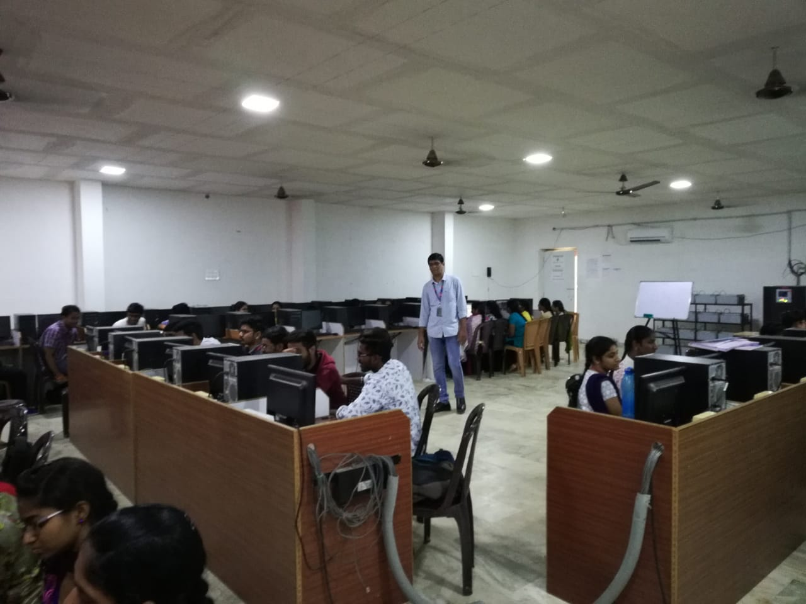
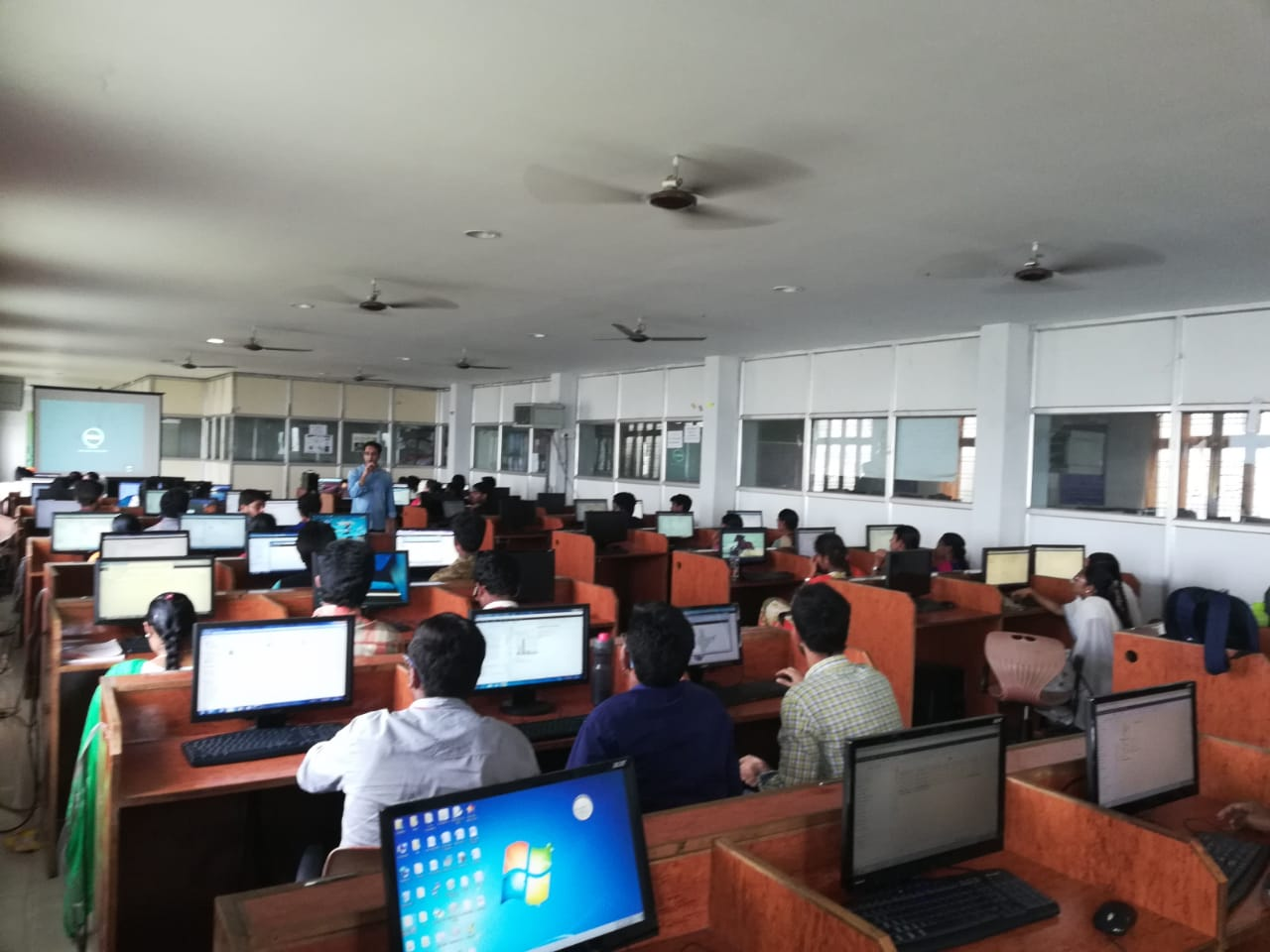

Advanced Database Concepts DB2
Trainer 1:-
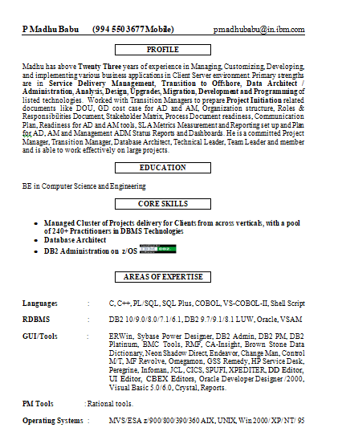

Trainer 2:-
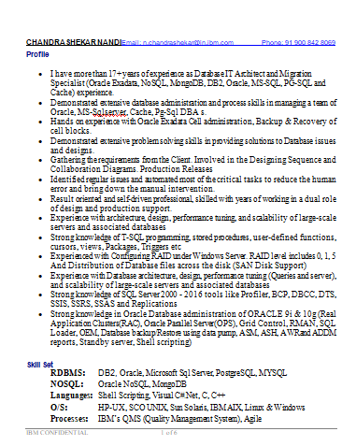

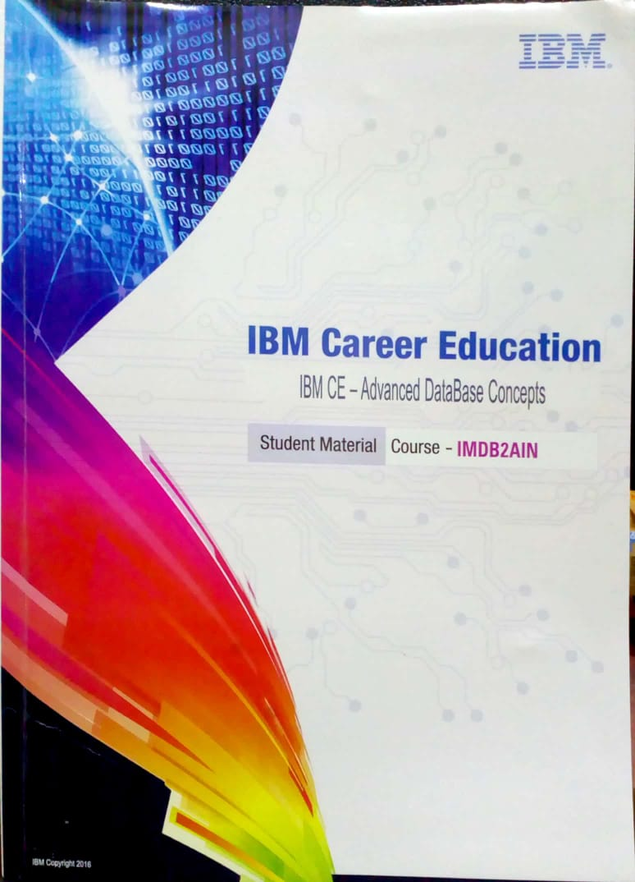
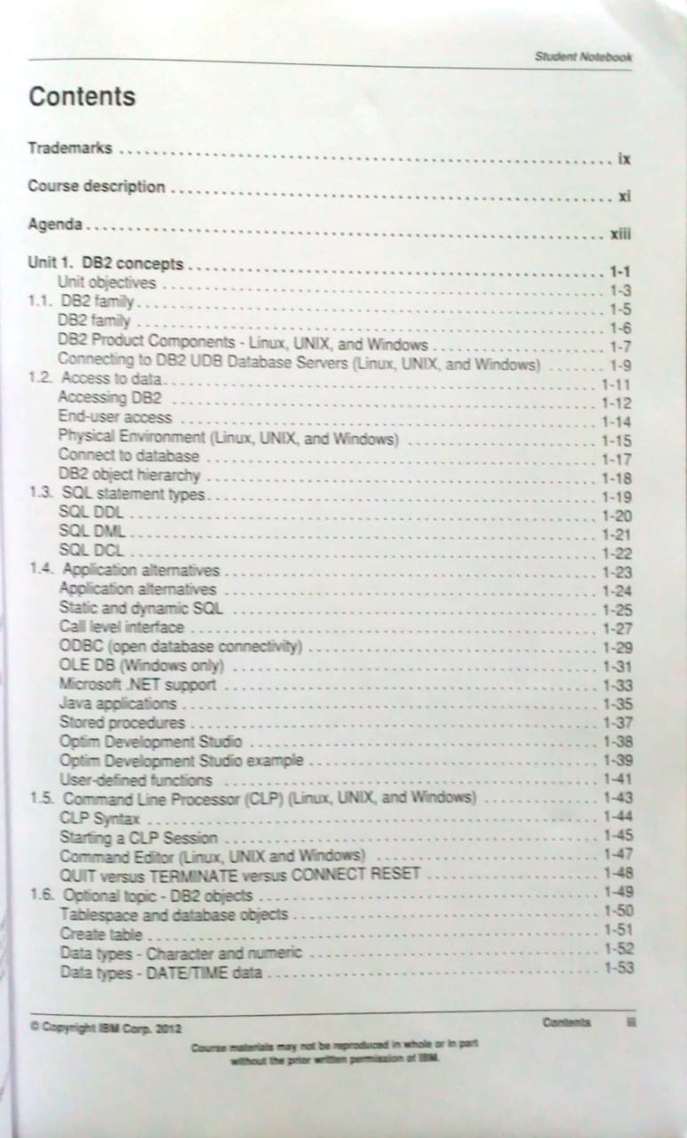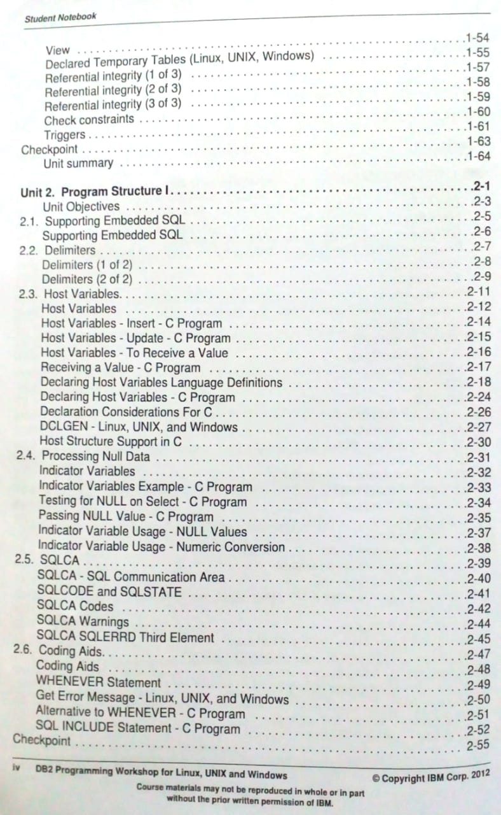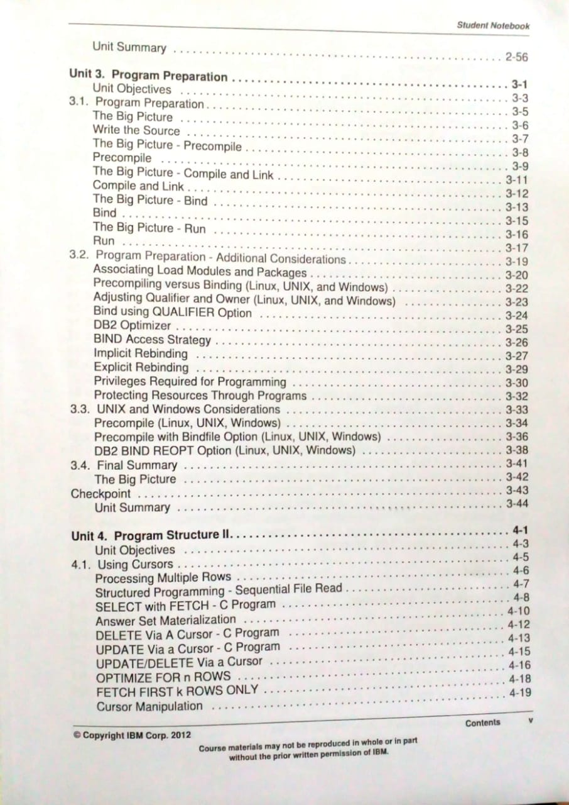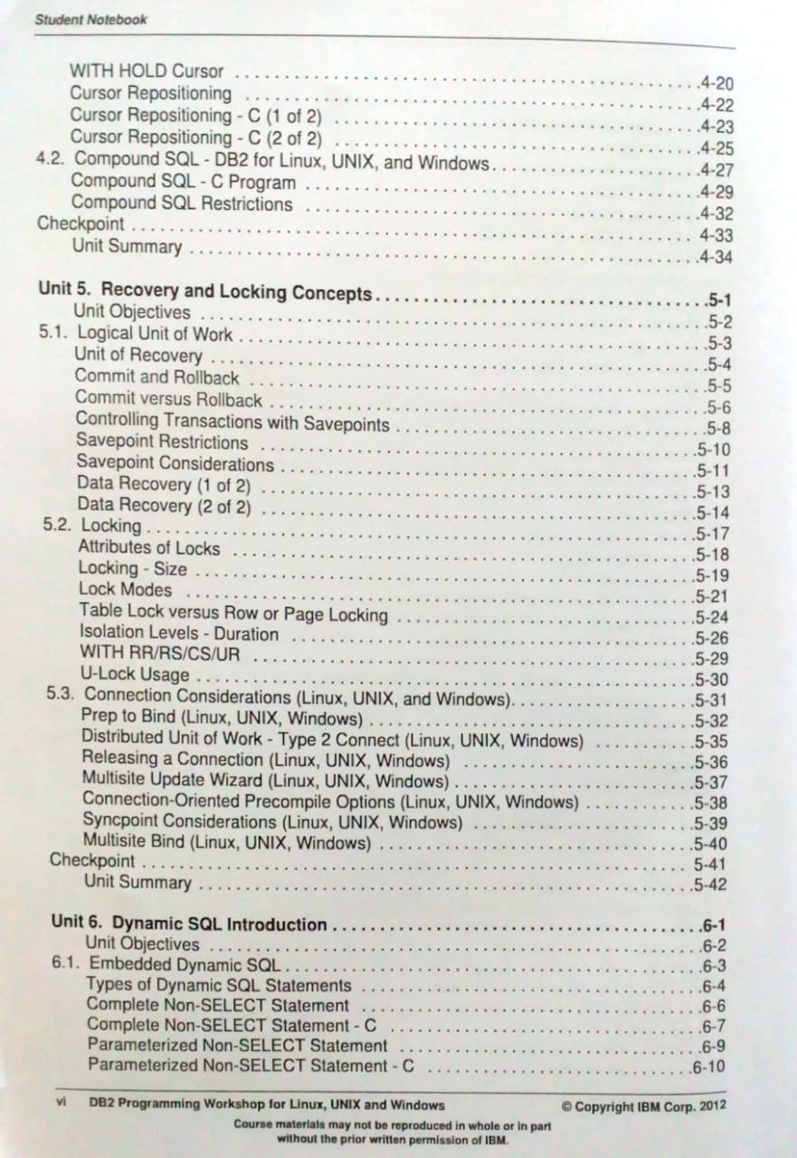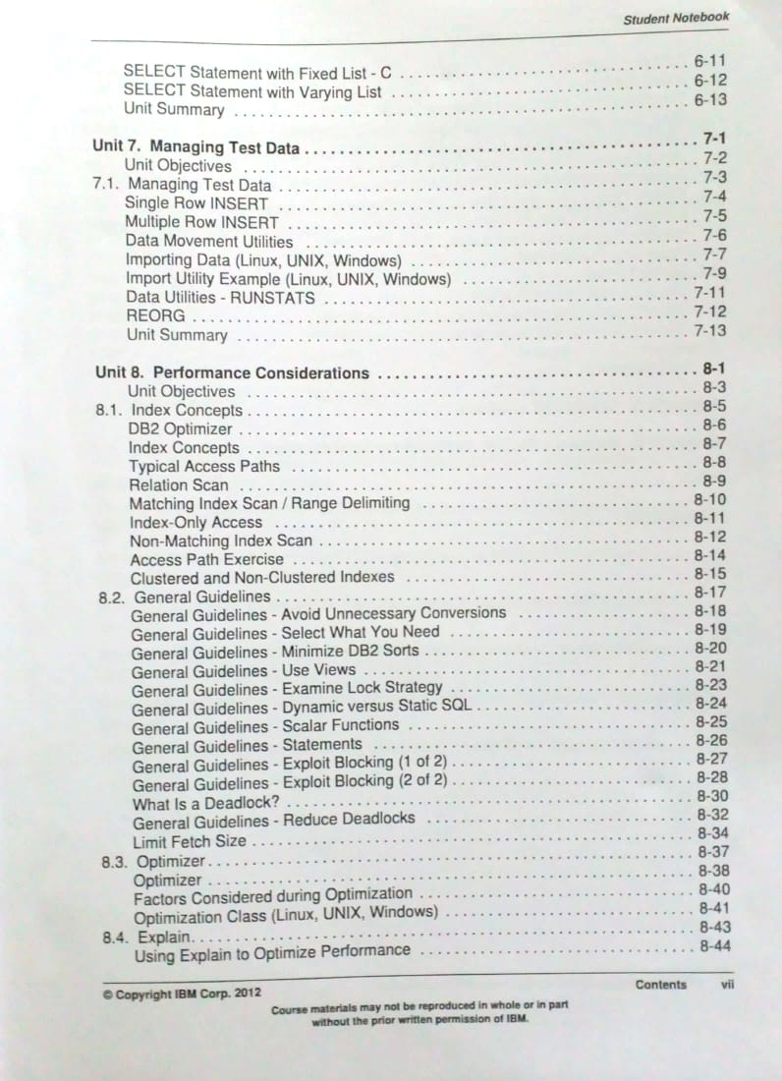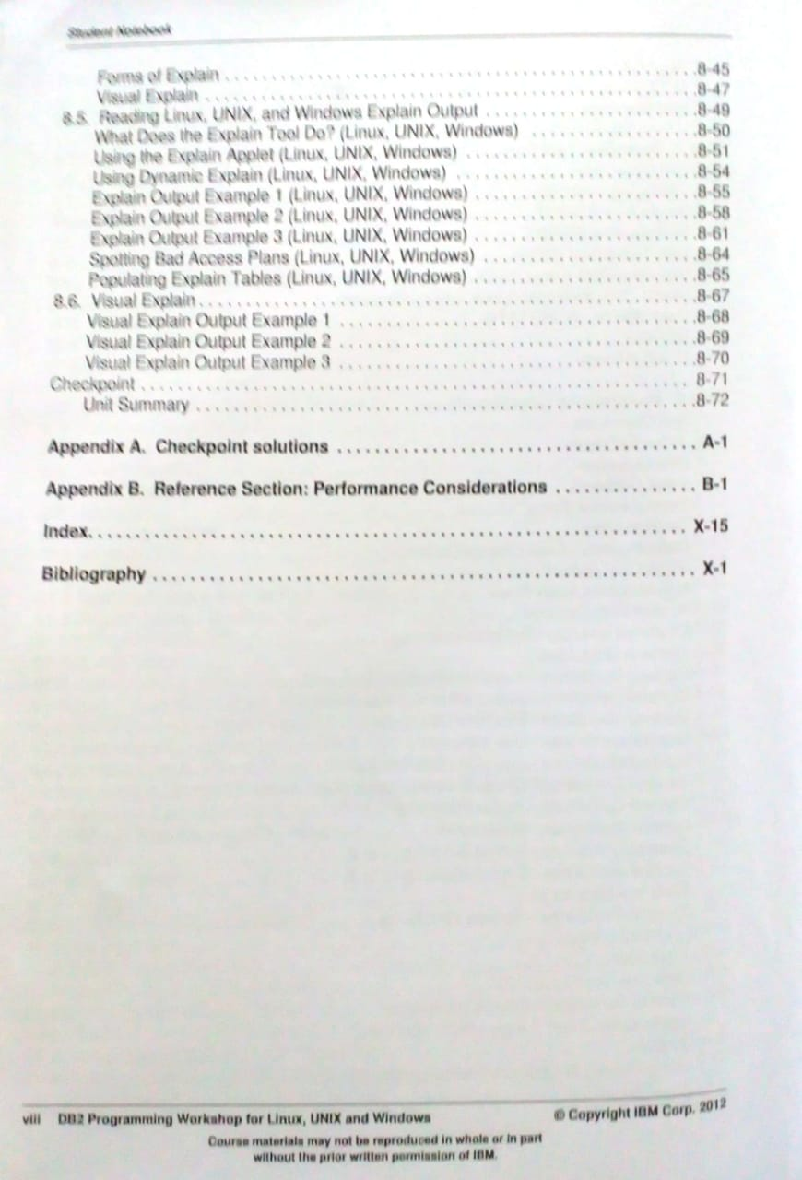
BATCH 1:-
Slno | Student Name | CE Reg No | Course / Project Name | Technologies  Used
1 | YARRAMSETTI NAGA LAKSHMI | 16NG1A0453 | Advanced Database | DB2
2 | MUNGI PRIYANKA | 16NG1A0453 | Advanced Database | DB2
3 | MAMIDI BHANUSRI | 16NG1A0435 | Advanced Database | DB2
4 | SIRIGINEEDI VEERA NAGA DURGA DEVI | 16NG1A0448 | Advanced Database | DB2
5 | GOGINENI KALPANA | 16NG1A0414 | Advanced Database | DB2
6 | GOPARAJU BALA SARASWATHI | 16NG1A0417 | Advanced Database | DB2
7 | BACHINABOYINA LAKSHMI PRASANNA | 16NG1A0403 | Advanced Database | DB2
8 | Atmuri Narasimha Raju | 16NG1A0402 | Advanced Database | DB2
9 | BANTUMILLI VAMSI PRIYA | 16NG1A0404 | Advanced Database | DB2
10 | PEDAMALLU KAILASH | 17NG5A0406 | Advanced Database | DB2
11 | MAMIDI BHANU PRAKASH | 17NG5A0403 | Advanced Database | DB2
12 | KADIYALA SAVIKHYA | 17NG5A0402 | Advanced Database | DB2
13 | PATHAN NASEEMA | 17NG5A0405 | Advanced Database | DB2
14 | PINNAMANENI MANUSHA | 17NG5A0407 | Advanced Database | DB2
15 | GINNI DIVAKAR REDDY | 16NG1A0413 | Advanced Database | DB2
16 | GADDE DIVYA | 16NG1A0412 | Advanced Database | DB2
17 | GUJJULA BHARGAVI | 16NG1A0423 | Advanced Database | DB2
18 | KAMBHAMPATI RADHIKA | 16NG1A0427 | Advanced Database | DB2
19 | ATCHYUTHA SNEHA LATHA | 16NG1A0401 | Advanced Database | DB2
20 | PAMU RAMYASRI | 17NG5A0404 | Advanced Database | DB2
21 | POTHARAJU JHANSI DIVYA | 16NG1A0446 | Advanced Database | DB2
22 | KUNCHAM SAI LOKESH | 16NG1A0432 | Advanced Database | DB2
23 | PAMMI LAHARI | 16NG1A0443 | Advanced Database | DB2
24 | CHIMAKURTHI VENKATADURGA ASHOK KUMAR | 17NG5A0401 | Advanced Database | DB2
25 | Chinthamsetty Srilakshmi Manijyothi | 16NG1A0409 | Advanced Database | DB2
26 | SRIPATHI KRISHNA KUMARI | 17NG5A0409 | Advanced Database | DB2
27 | POKURI VINEETH | 16NG1A0444 | Advanced Database | DB2
28 | Lokanatham Bhanu Sree | 16NG1A0433 | Advanced Database | DB2
29 | KANCHARLA RAJESH | 16NG1A0428 | Advanced Database | DB2
30 | MAJJI VIJAYA KUMARI | 16NG1A0434 | Advanced Database | DB2
31 | RAJESETTY NAGA SOWMYA SRI | 17NG5A0408 | Advanced Database | DB2
32 | POTHANA VANITHA | 16NG1A0445 | Advanced Database | DB2
33 | MYNENI DEEPIKA | 16NG1A0439 | Advanced Database | DB2
34 | JAMPANA ANUSHA | 16NG1A0424 | Advanced Database | DB2
35 | CHINTA LALITHA DEVI | 16NG1A0408 | Advanced Database | DB2
36 | KAKOLLU MOUNIKA | 16NG1A0425 | Advanced Database | DB2
37 | GUDAVALLI VENKATA SAMYUKTHA | 16NG1A0421 | Advanced Database | DB2
38 | PRABHALA VENKATA NAGA AKHILA SUBHASRI | 16NG1A0447 | Advanced Database | DB2
39 | MUDDINENI PAVAN KUMAR | 16NG1A0437 | Advanced Database | DB2
40 | Palanki Kartheek | 16NG1A0442 | Advanced Database | DB2
41 | TALARI SRIKANTH | 16NG1A0449 | Advanced Database | DB2
42 | GONA DHANALAKSHMI | 16NG1A0416 | Advanced Database | DB2
43 | EESANI PRASANNA | 16NG1A0411 | Advanced Database | DB2
44 | PADUCHURI ROHIT VENKAT PAVAN | 16NG1A0441 | Advanced Database | DB2
45 | TUMMALA NIKHILESH BABU | 16NG1A0450 | Advanced Database | DB2
46 | GOTTAM NIKHIL KUMAR | 16NG1A0420 | Advanced Database | DB2
47 | VEERANKI TEJA SIVA NAGA SAI | 16NG1A0451 | Advanced Database | DB2
48 | ESWARI PRIYANKA PASUPULATI | 15NG1A04A2 | Advanced Database | DB2
49 | KAKUMANU DAANA VARSHITHA | 16NG1A0426 | Advanced Database | DB2
50 | GOPAVARAPU NAVEEN KUMAR | 16NG1A0418 | Advanced Database | DB2

BATCH 2:- ECE & EEE
slno | Student Name | CE Reg No | Course / Project Name | Technologies  Used
1 | VEMU PRASANTHI | 16NG1A0498 | Advanced Database | DB2
2 | YENUGADHATI RUPA SESHA VARMA | 16NG1A04A1 | Advanced Database | DB2
3 | MUDRABOYINA RAMYA | 17NG5A0413 | Advanced Database | DB2
4 | GANGURI SRINIVASA NARASIMHA TENDULKAR | 16NG1A0461 | Advanced Database | DB2
5 | YEDLA BINDU SRAVANI | 16NG1A04A0 | Advanced Database | DB2
6 | PITTA SUVARNA KUMARI | 17NG5A0418 | Advanced Database | DB2
7 | BOYAPATI NAVYA SRI | 16NG1A0456 | Advanced Database | DB2
8 | TUMULURI HEMANJALI | 17NG5A0411 | Advanced Database | DB2
9 | KONDAPALLI SRAVANI | 16NG1A0473 | Advanced Database | DB2
10 | MANDALA MANOJ KUMAR | 16NG1A0478 | Advanced Database | DB2
11 | VELLATURI LEELAPARIMALA | 17NG5A0416 | Advanced Database | DB2
12 | SARIPALLI PHANI KUMAR REDDY | 17NG5A0415 | Advanced Database | DB2
13 | THERLAPU SRAVANI | 17NG5A0410 | Advanced Database | DB2
14 | MANNAM LAKSHMIGANESH | 16NG1A0479 | Advanced Database | DB2
15 | Boddani NagaLakshmi | 16NG1A0455 | Advanced Database | DB2
16 | NARIKADAMILLI CHANDRA SEKHAR | 17NG5A0414 | Advanced Database | DB2
17 | MARUBOINA LAKSHMI SIVA GOPI RAJU | 16NG1A0481 | Advanced Database | DB2
18 | PASUPULETI CHITRA BHANU SRI | 16NG1A0486 | Advanced Database | DB2
19 | THADISETTI SIREESHA | 16NG1A0493 | Advanced Database | DB2
20 | DUDDUKUNTA HEMAMBIKA | 16NG1A0459 | Advanced Database | DB2
21 | SHAIK DULISHA BEGUM | 17NG5A0419 | Advanced Database | DB2
22 | GANTA BHUVANESWARI | 16NG1A0462 | Advanced Database | DB2
23 | BANDUCHODE HARINIDHI | 16NG1A0454 | Advanced Database | DB2
24 | GUNTUR ESWARA SAI | 16NG1A0202 | Advanced Database | DB2
25 | KONALI RAJITHA | 16NG1A0203 | Advanced Database | DB2
26 | PRATHIPATI RAJENDRA KUMAR | 16NG1A0204 | Advanced Database | DB2
27 | SEEDRALA BHARATH KUMAR | 16NG1A0205 | Advanced Database | DB2
28 | THOMMANDRU RAJA VIJAY RAJU | 16NG1A0206 | Advanced Database | DB2
29 | THUMATI MANOHAR | 16NG1A0207 | Advanced Database | DB2
30 | VEMULAPALLI MEGHASHYAM | 16NG1A0208 | Advanced Database | DB2
31 | AKKINENI NIKHITHA | 17NG5A0201 | Advanced Database | DB2
32 | CHALAMALASETTY SAIRAM | 17NG5A0202 | Advanced Database | DB2
33 | GODAVARTHI INDRANI | 17NG5A0203 | Advanced Database | DB2
34 | GOPISETTI PURNA ARAMA CHANDRA | 17NG5A0204 | Advanced Database | DB2
35 | JONNALAGADDA RAJESH | 17NG5A0205 | Advanced Database | DB2
36 | KONAKANCHI DURGA VARA PRASAD | 17NG5A0206 | Advanced Database | DB2
37 | M SAI KRISHNA | 17NG5A0207 | Advanced Database | DB2
38 | NARALA RAVI CHANDRA VEERRAJU | 17NG5A0208 | Advanced Database | DB2
39 | PATTAMSETTI ABHINAV | 17NG5A0211 | Advanced Database | DB2
40 | N P SRI VENU GOPALA KRISHNA | 17NG5A0209 | Advanced Database | DB2
41 | PADAMATA NAGA SAI | 17NG5A0210 | Advanced Database | DB2
42 | SONGA DILEEP KUMAR | 17NG5A0212 | Advanced Database | DB2
43 | SYED MUJEEBUL RAHIMAN | 17NG5A0213 | Advanced Database | DB2
44 | YARAJARLA LAKSHMI TIRUPATHIMMA | 17NG5A0215 | Advanced Database | DB2
45 | BURRA NANI | 17NG5A0216 | Advanced Database | DB2
46 | BUGGALA KARIMULLA | 17NG5A0217 | Advanced Database | DB2
47 | DURGA SAI UMA SHANKAR | 17NG5A0218 | Advanced Database | DB2
48 | MANDAPAKA KRISHNAVENI | 17NG5A0219 | Advanced Database | DB2
49 | NARALA RAVI CHANDRA VEERRAJU | 17NG5A0208 | Advanced Database | DB2
50 | SANGAVRAPU RAMU | 17NG5A0221 | Advanced Database | DB2
 | TADISETTI MOHAN | 17NG5A0214 | Advanced Database | DB2

